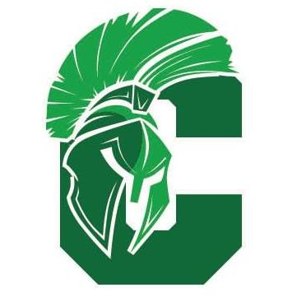
Spartan Archery
Parents and Archers,
Last year, the Calvary Christian School Archery Club had the opportunity to compete against another school located in Decatur, Illinois. I believe it was a great experience and I would like to offer that to you again. This year, the other coach and I, have looked at how we might be able to add to the experience. This year, our shoots will take place at Big Bucks Archery Shop in St. Henry, Ohio. Hosting our shoots there will provide targets and equipment that our schools will not have to transport back and forth. The greatest advantage this location will offer is the variety of shooting competition we can offer. We will be able to offer indoor round target competition as well as 3D competition. Students will have the option of what category they would like to compete in as well as what equipment they would like to shoot. Competing students, parents or guardians will be required to sign a release waiver for Big Bucks Archery Shop.
This year, we will be having four shoots. The dates for these shoots are March 4th & 11th and April 1st & 8th (dates are subject to change). You are invited to participate in all of these competitions or as many as you can. Award certificates will be presented to the top shooters in each category.
Archery Club is for students in grade 5 through 12.
Practices will begin February 3rd and be held each following Wednesday from 3:30-4:30 until the end of the season (practices are subject to cancellation). To signup for Archery Club, visit ccsspartans.com, CCS App, or stop in the office.
If you have any questions, please contact me. Looking forward to another fun archery season.

Donny Macaluso
937-599-4775
dmacaluso@calvarybellefontaine.org

